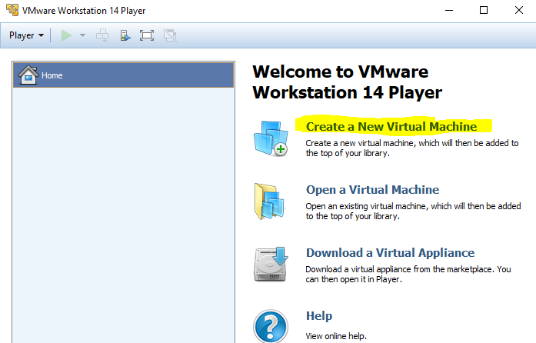

Use the Browse… button to tell Workstation Player where the ISO file lives.

**Note**: When Workstation Player recognizes the OS it is about to install, it will offer you the choice to use “Easy Install.” This allows you to pre-enter the data the installation will need, such as computer name, user name, keyboard type, etc. It will then enter those items for you when the OS installs, which speeds the installation process. If you want to see the questions the OS asks during installation and answer them yourself, select “I will install the operating system later.” You will have to connect the VM to the installation ISO manually, and then the installation will proceed just as it does on fresh hardware.

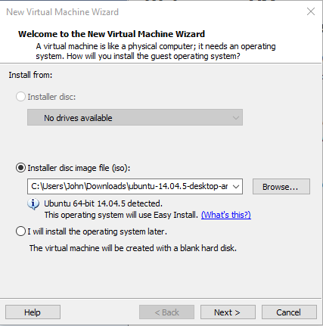

# Continue, using the Easy Button

Linux user names must be lower case letters. Don’t forget your password!!

You can use a simple password here, unless you plan to store secrets on the VM.

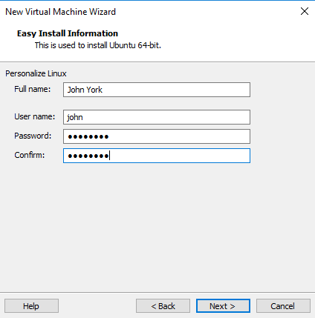

The standard location is C:\Users\[your user name]\Documents\Virtual Machines, which is fine. Give the VM any name you like, within reason.

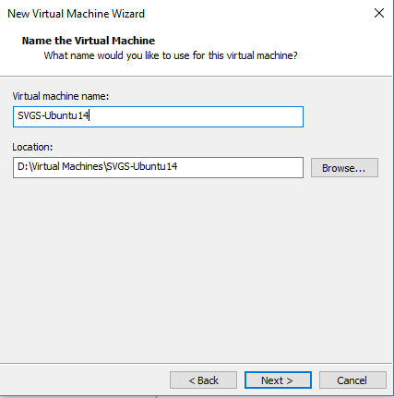

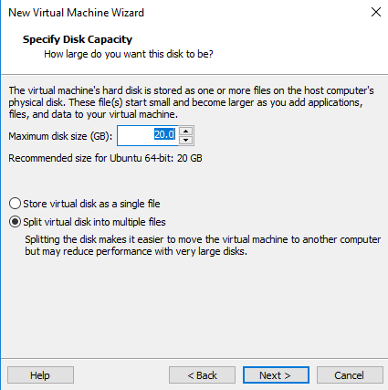

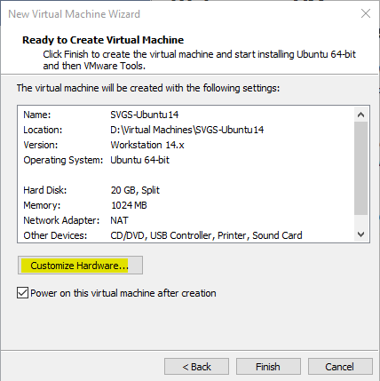

Your VM will run better if you give it 2 CPUs and 4 GB of RAM

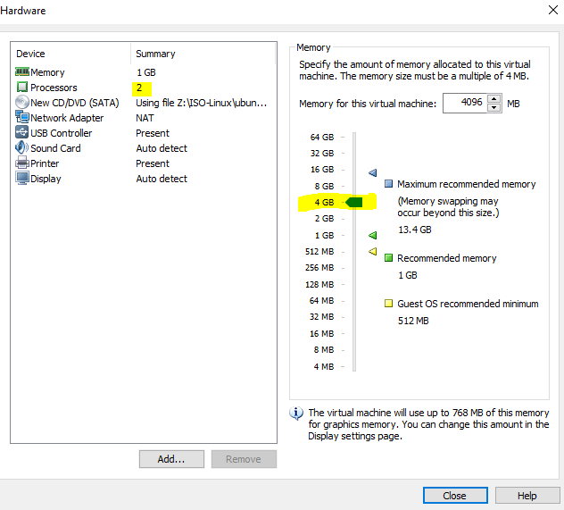

At this point, the installation will proceed on its own, and you should eventually see an Ubuntu login screen.

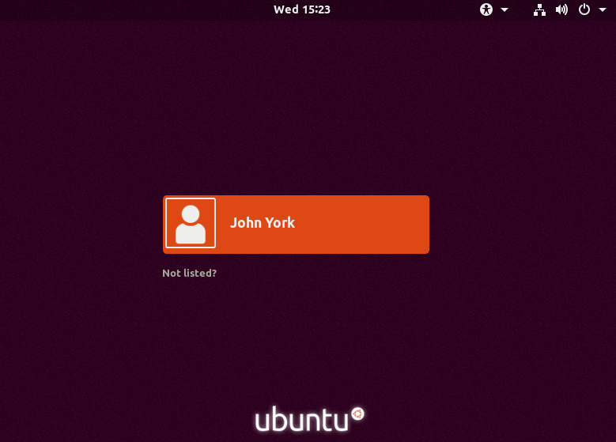

# Note: If you elected not to use Easy Install, or, Installing Ubuntu the hard way

If you told Workstation Player that you would install the OS later, you will find the VM fails to boot because it cannot find media.

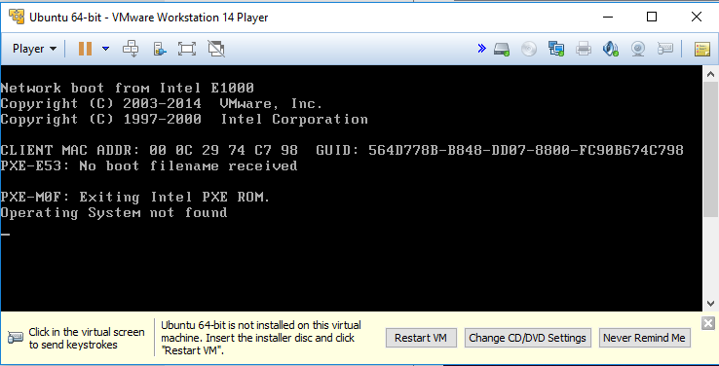

Fix that by using the VM settings to tell the VM to boot from the installation ISO. You can click on “Change CD/DVD Settings.” Be sure the Device status is Connected and Connect at power on. Use the browse button to find the ISO file you wish to install.

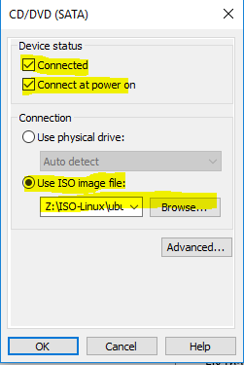

**Or**, you can select Player > CD/DVD > Settings or Player > Manage > Virtual Machine Settings…

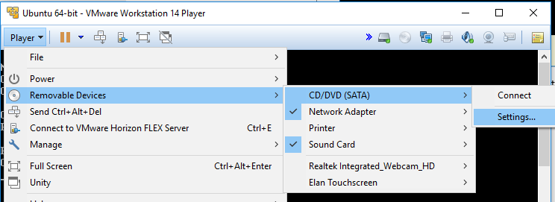

Then make the same settings as before.

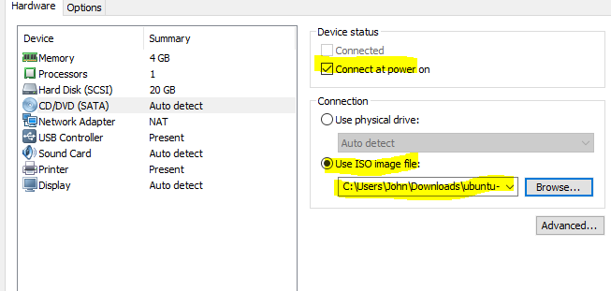

When the VM boots, it should start the installation process from the ISO file. If you select “Try Ubuntu”, the VM will boot entirely from the CD (or ISO), will always require the CD/ISO to boot, and changes you make will be lost any time the VM restarts. This is called a “Live CD” installation” and has the advantage of taking very little disc space. We will install our VM on the files in the VM folder so that we don’t need the ISO to boot (after the installation) and any changes we make will be retained between reboots.

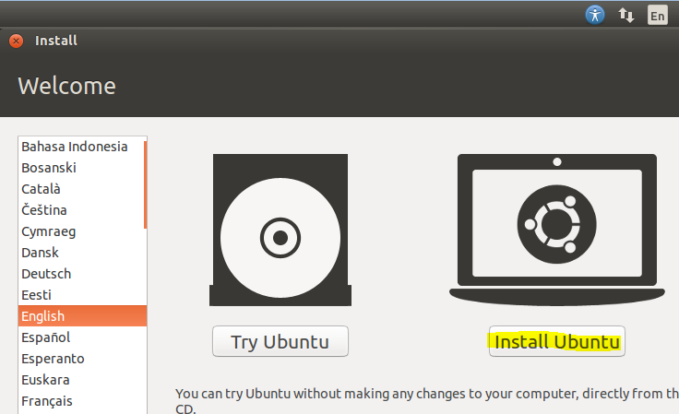

SVGS has lots of bandwidth, so downloading updates during installation is not a problem.

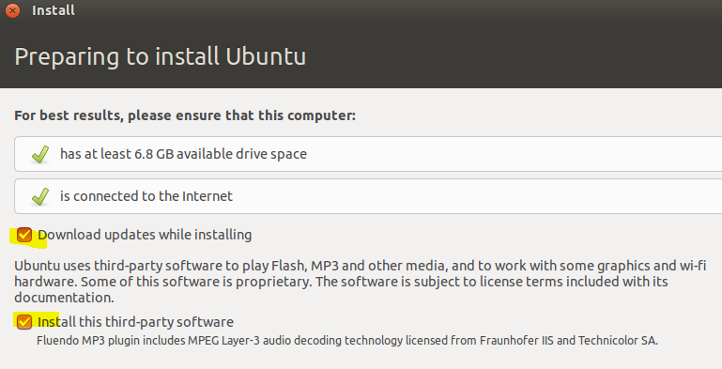

If we were installing on hardware we would want to ensure that there is nothing important on the hard disk, as it will be overwritten. On a VM, the “hard disc” is just a file that hasn’t been created yet so there is no danger of losing data. LVM is the most current disc format. You can use it or not, as you choose.

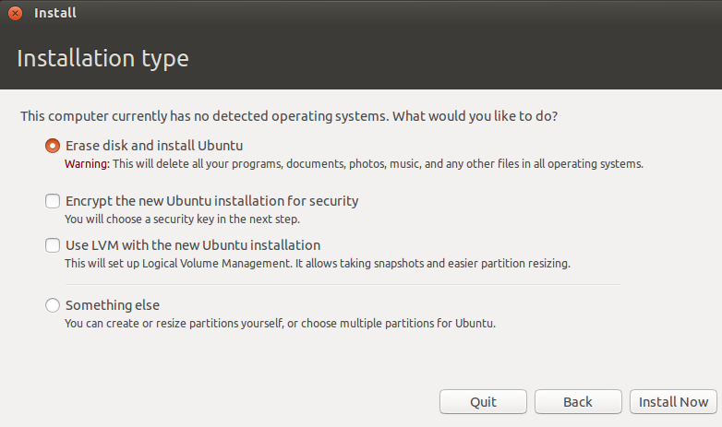

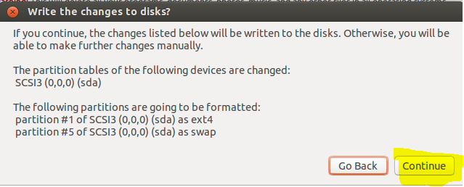

Some screens have been skipped. Note that Linux requires the username to be in lower case.

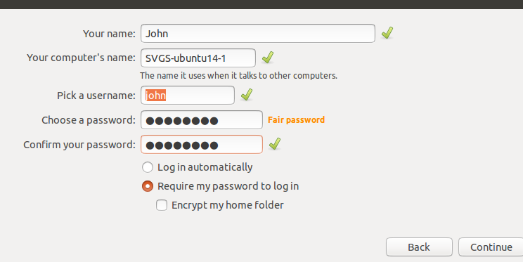

Done! (Almost)

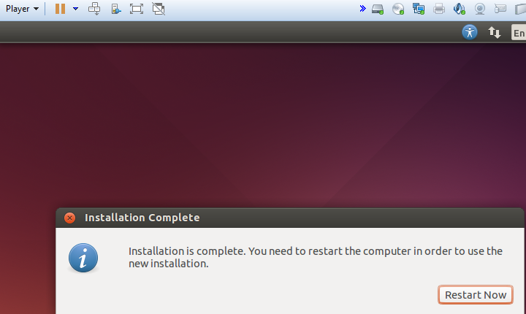

We don’t want to boot from the CD/ISO anymore, so disconnect it.

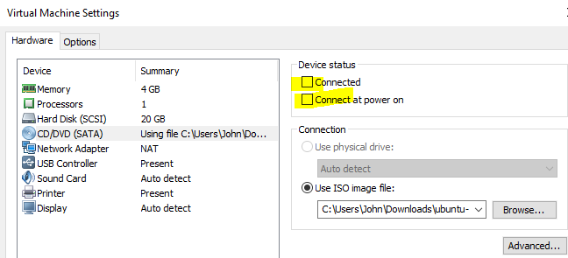

We want to stay on the old version 14 so we are using the same version as CyberPatriots, so don’t let it upgrade.

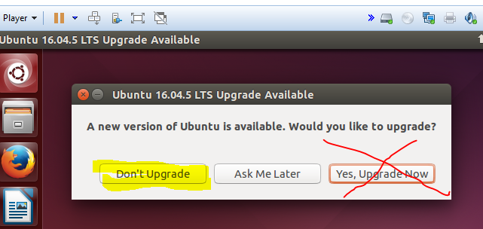

We do want to install updates for version 14, however.

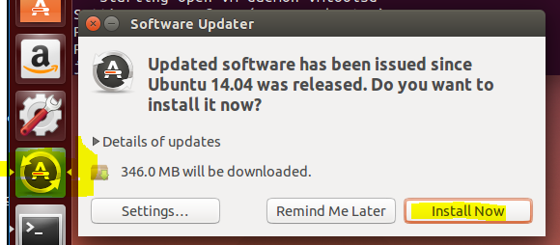

## Installing VMware Tools

Note: the easy install does this for you, so it is only necessary to install VMware tools if you did the manual installation. VMware tools provide better drivers and software to make the OS easier to use in a VM environment. VMware Workstation Player comes with tools for several OSs, but even VMware says the tools that the distributions support are better than the tools they provide. So, don’t do this:

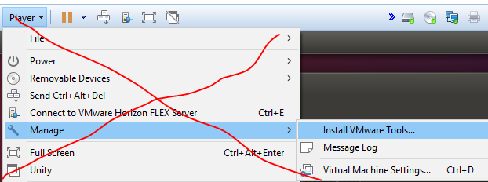

You can install the distribution’s version, open-vm-tools, from the command line very quickly. The commands are:  
sudo apt-get install open-vm-tools  
sudo apt-get install open-vm-tools-desktop

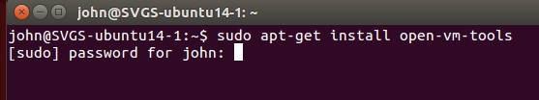

Once you put in your password and tell it to install, it will be done in moments.